Name –Ayan Sadhukhan

Registration Number- 19BEC1448

*Question 1:*

Mr X wants new carpeting in his family room. Her family room is a 10ft by 9ft rectangle. How much carpeting does he need to buy to cover his entire family room?. The price one square feet is 200 rupees. Write a recursive algorithm to find the total cost for carpeting the room and implement your algorithm in any programming language.

*Code:*

#include<stdio.h>

int sum(int x,int y,int s)

{

if (y==x)

return s;

else

y=y+1;

return s+200+sum(x,y,s);

}

int main()

{

int l,w;

printf("Enter the length of the room :");

scanf("%d",&l);

printf("\nEnter the width of the room :");

scanf("%d",&w);

int p=l\*w;

printf("The total cost for carpeting the room is %d\n",sum(p,0,0));

return 0;

}

*Output:*

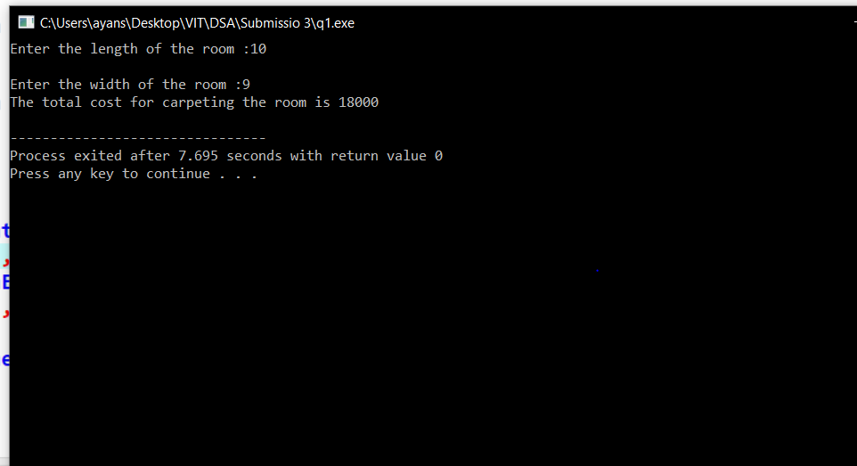

*Question 2:*

A sample of a radioactive substance is expected to decay by 15 percent each hour. What is the weight w(t) of the sample at *t* hours later in the experiment, where w(0) = 100 is the initial weight. Design a recursive algorithm to find the weight after *7* hours and implement your algorithm in any programming language.

*Code:*

#include<stdio.h>

int sum(int x,int y,int s)

{

if (y==x)

return s;

else

y=y+1;

s=s-(.15\*s);

return sum(x,y,s);

}

int main()

{

int l,w,p;

printf("Enter the time :");

scanf("%d",&p);

printf("The amount remaining after decaying is : %d\n",sum(p,0,100));

return 0;

}

*Output:*

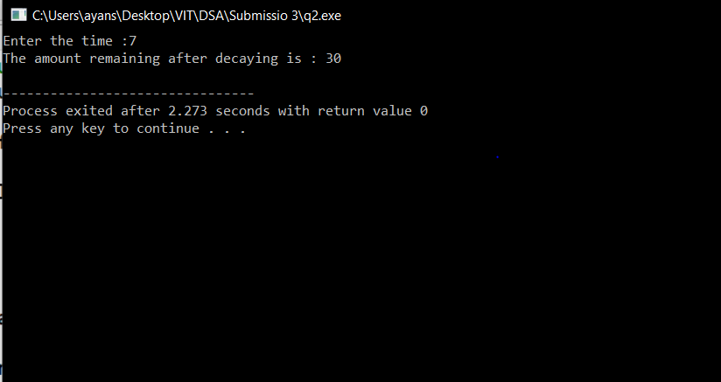

*Question 3:*

The Lucas number is same as the Fibonacci number . It is given by the following recurrence equation : L1 =1 , L2=3 and Ln= L n-1 +L n-2 n>2 . Write a recursive algorithm to find nth Lucas number and implement your algorithm in any programming language.

*Code:*

#include<stdio.h>

int sum(int x,int y,int a,int b,int s)

{ int j;

if (x==y)

return s;

else

j=a+b;

y=y+1;

s=j;

a=b;

b=j;

return sum(x,y,a,b,s);

}

int main()

{

int l,w,p;

printf("Enter the term you want to search for (greater than 2) :");

scanf("%d",&p);

printf("The %d term of the lucas series is %d",p,sum(p,2,2,1,0));

return 0;

}

*Output:*

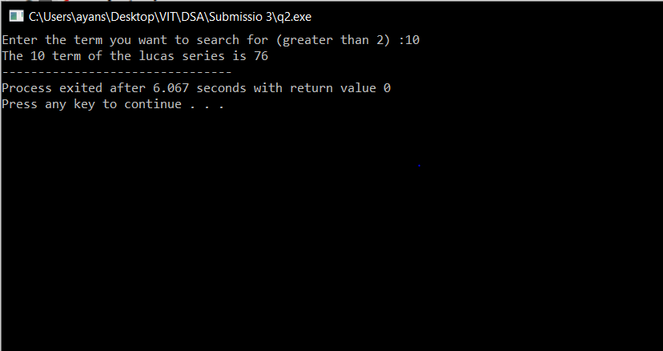

*Question 4:*

Consider *x* and *y* are two positive integers, the number digits in *x* is greater than or equal to 1 and the number of digits in *y* is exactly one. Design two algorithms( sequential and recursive) to check the number *y* is presented in digits of the number x or not. Implement your algorithm in any programming language. For example , your algorithm will produce the output ‘yes’ for the input x=12678 and y=2 and ‘no’ for the input x=12678 and y=5 .

*Code(Using recursion):*

#include<stdio.h>

int sum(int x,int y,int j)

{

if (y==j)

return 1;

else if (x==0)

return 0;

else

{

j=x%10;

x=x/10;

return sum(x,y,j);

}

}

int main()

{

int x,y;

printf("Enter the number :");

scanf("%d",&x);

printf("\nEnter the digit to be searched :");

scanf("%d",&y);

if (sum(x,y,0)==1)

{

printf("Yes");

}

else

{

printf("No");

}

return 0;

}

*Output:*

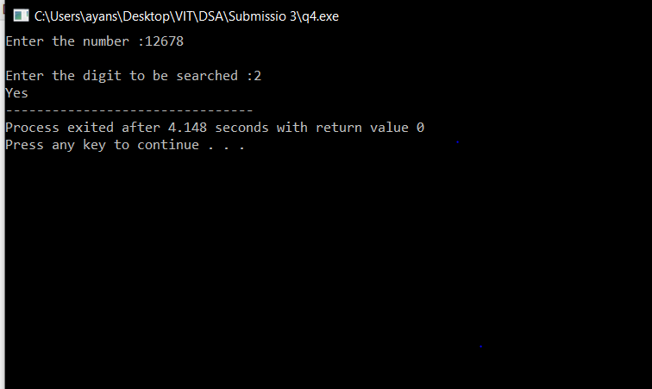

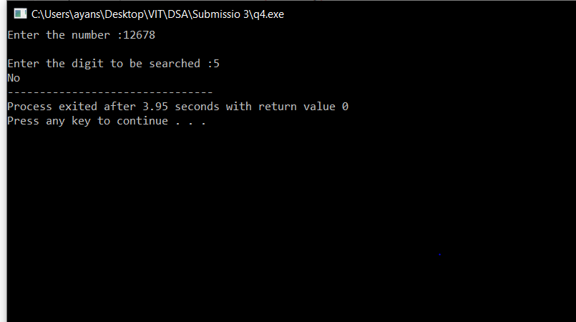

*Code(Sequential):*

#include<stdio.h>

int main()

{

int x;

int y;

printf("Enter the number :");

scanf("%d",&x);

printf("Enter the digit to be searched :");

scanf("%d",&y);

int f=0,d=0;

while(x!=0)

{

d=x%10;

x=x/10;

if (d==y)

{

f=1;

break;

}

}

if(f==1)

{

printf("Yes");

}

else

{

printf("No");

}

}

*Output:*



